7.17: a) Solving Eq. (7.9) for 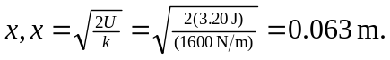
b) Denote the initial height of the book as h and the maximum compression of the spring by x. The final and initial kinetic energies are zero, and the book is initially a height 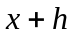 above the point where the spring is maximally compressed. Equating initial and final potential energies, 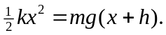 This is a quadratic in x, the solution to which is
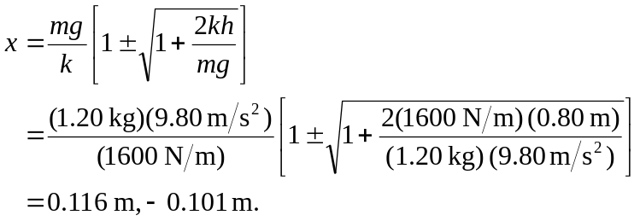
The second (negative) root is not unphysical, but represents an extension rather than a compression of the spring. To two figures, the compression is 0.12 m.

